|  |
| --- |
| NM2023TMID01931’s |
| HOW TO ADD A GOOGLE ANALYTICS TO A WEBSITE |
| **Brand Name : Spider Code Academy**  **Category : Online Community**  **Target Audience : Students & Working Professionals   Email :** [**spidercodeacademy@gmail.com**](mailto:spidercodeacademy@gmail.com)  **Create a Blog website :** [**www.blogger.com**](http://www.blogger.com) |

**TABLE OF CONTENTS**

1. Brand name with Brand Email

2. Creating a website in Blogger.com

3. Generating a link of a website

4. Entering into Google Analytics

5. Adding an Account name

6. Creating a property

7. Describing a business

8. Choosing a business objective

9. Choosing a platform as Web

10. Setting up data stream by website URL

11. Generated Measurement ID with tag instructions

12. Copying tag instruction as installing manually

13. Editing HTML of blogger website in theme section

14. Pasting Google Tag after <head> tag

15. Generated Data Stream and Linked Analytics successfully

**INTRODUCTION**

In the ever-evolving digital landscape, understanding the intricacies of website performance is an indispensable tool for individuals and businesses seeking to establish a strong online presence. Web analytics provide a window into the behaviors and preferences of site visitors, offering actionable insights to shape and refine online strategies. At the forefront of web analytics tools stands ***Google Analytics***, a powerful and versatile platform that empowers website owners with the knowledge needed to optimize their digital footprint.

This project, titled ***"Adding Google Analytics to a Website***," is a comprehensive guide designed to demystify the process of integrating Google Analytics into a website. By following the structured steps outlined within this project, individuals and organizations can embark on a journey to harness the full potential of their online ventures.

The project commences with ***foundational steps such as identifying a brand name and creating a website, catering to novices in the digital realm***, while it simultaneously delves into the intricacies of implementing Google Analytics for the seasoned webmaster. Each subtopic is carefully detailed, offering clear and concise instructions for a successful setup.

In a world where data reigns supreme, the ability to access, interpret, and act upon insights is paramount. This project serves as a ***guiding light, illuminating the path to web analytics mastery, and ultimately, a deeper understanding of your online audience and website performance***. Whether you are an aspiring blogger, a small business owner, or an experienced web developer, this project empowers you to harness the full potential of your digital presence through Google Analytics.

**STEP 1: - BRAND NAME WITH BRAND EMAIL**

Establish a unique brand name and designate a brand-specific email address to begin the Google Analytics setup process. This ensures that your website is associated with your brand identity.

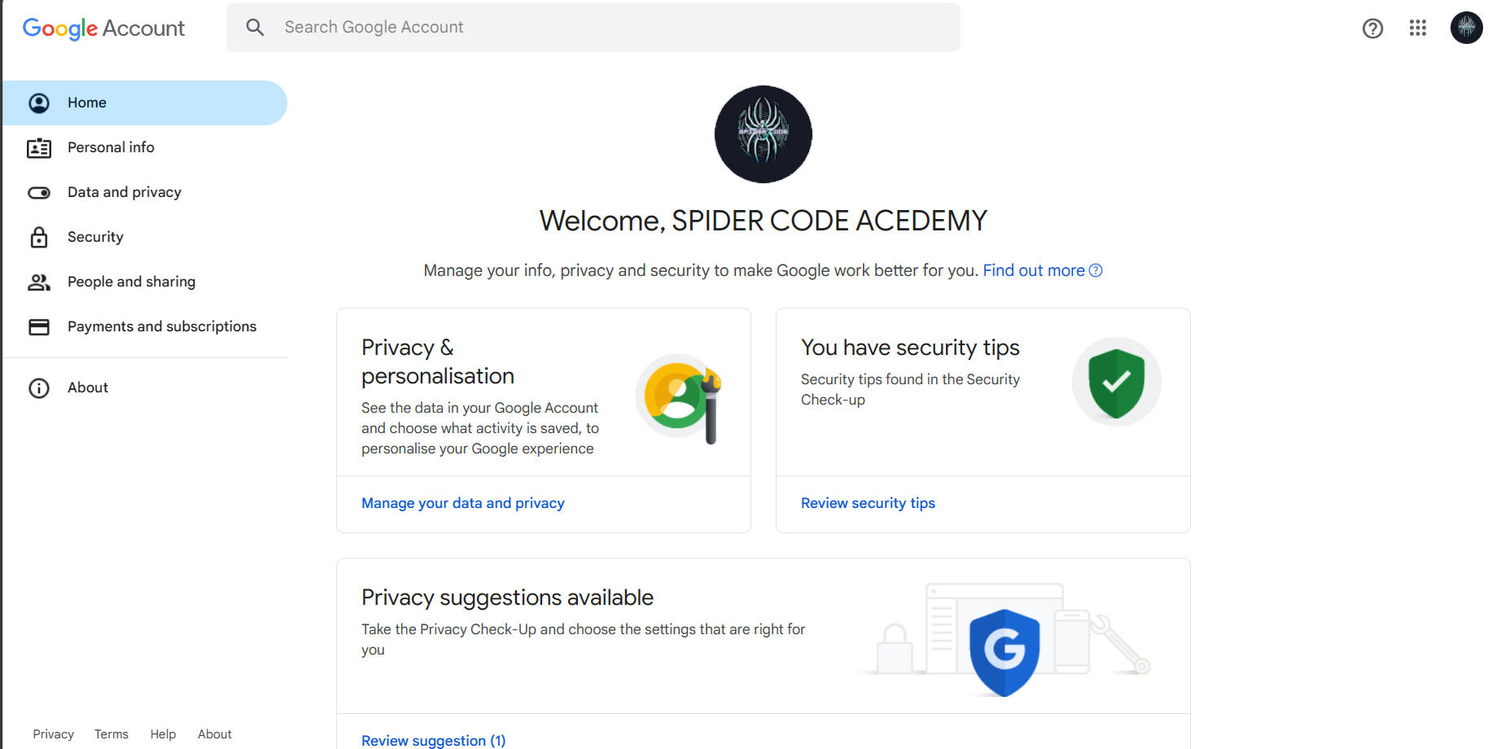

**STEP 2: - CREATING A WEBSITE USING BLOGGER.COM**

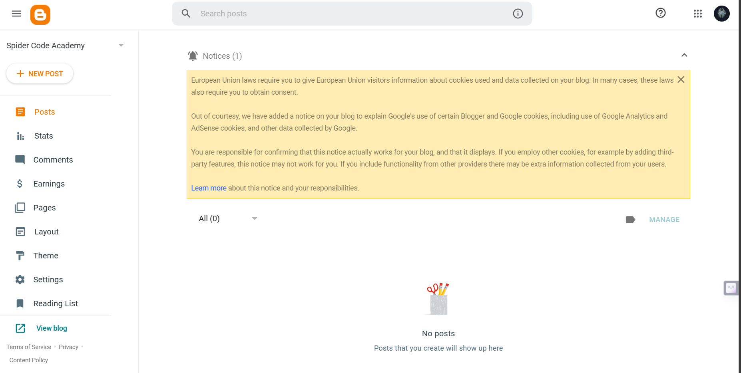 Create a website using the user-friendly Blogger.com platform, setting the stage for integrating Google Analytics with your website.

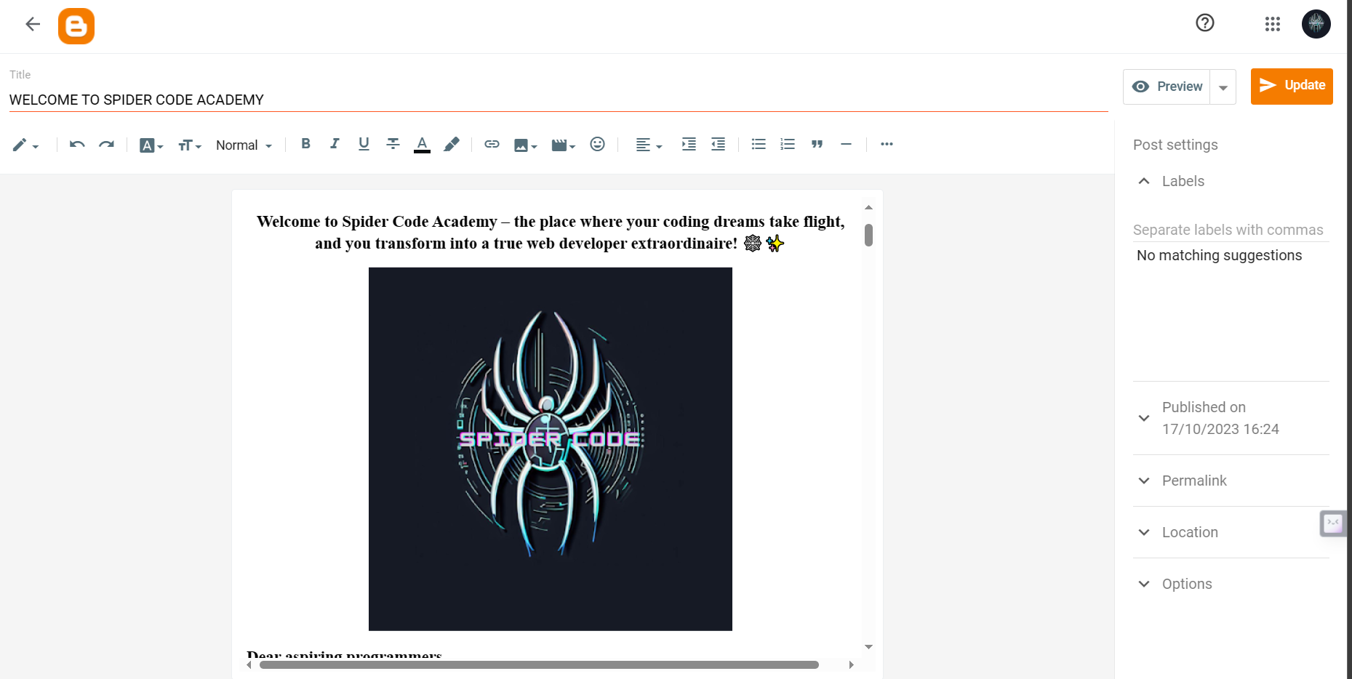

**STEP 3: - GENERATING LINK OF A WEBSITE**

Generate a URL for your website within the Blogger platform, allowing Google Analytics to identify and track your site.

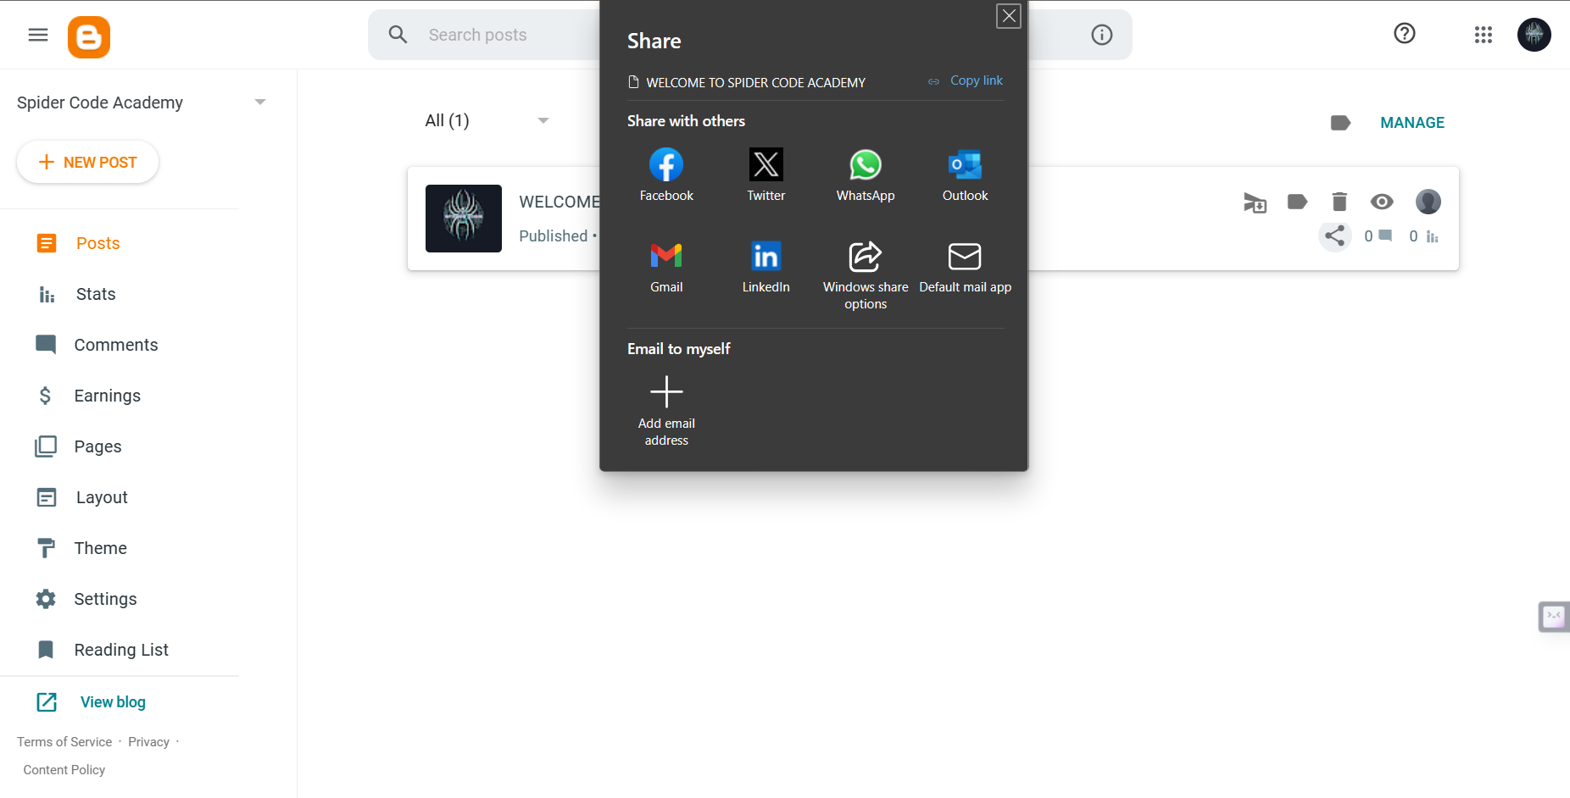

**STEP 4: - ENTERING INTO GOOGLE ANALYTICS**

Access the Google Analytics platform by visiting https://analytics.google.com to initiate the setup process.



**STEP 5: - ADDING AN ACCOUNT NAME**

Create an account within Google Analytics and give it a name corresponding to your website, laying the foundation for data collection.

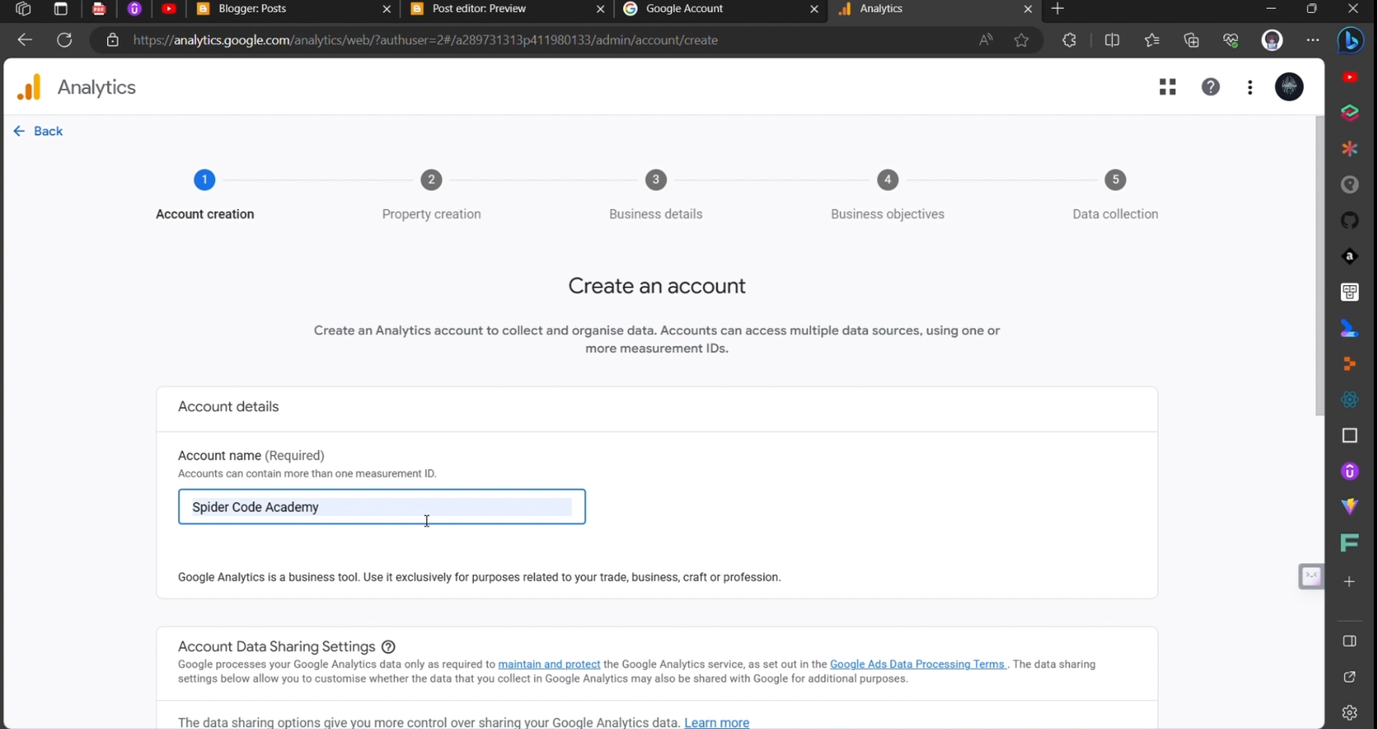

**STEP 6: - CREATING A PROPERTY**

Establish a property within the account, typically representing a specific website or app that you intend to track with Google Analytics.

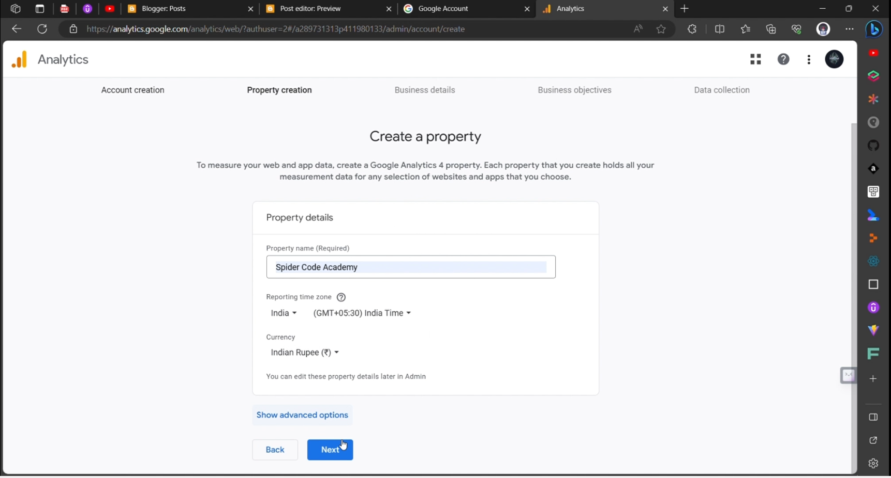

**STEP 7: - DESCRIBING A BUSINESS**

Provide a brief business description, helping Google Analytics understand your website's nature and purpose for more accurate data analysis.

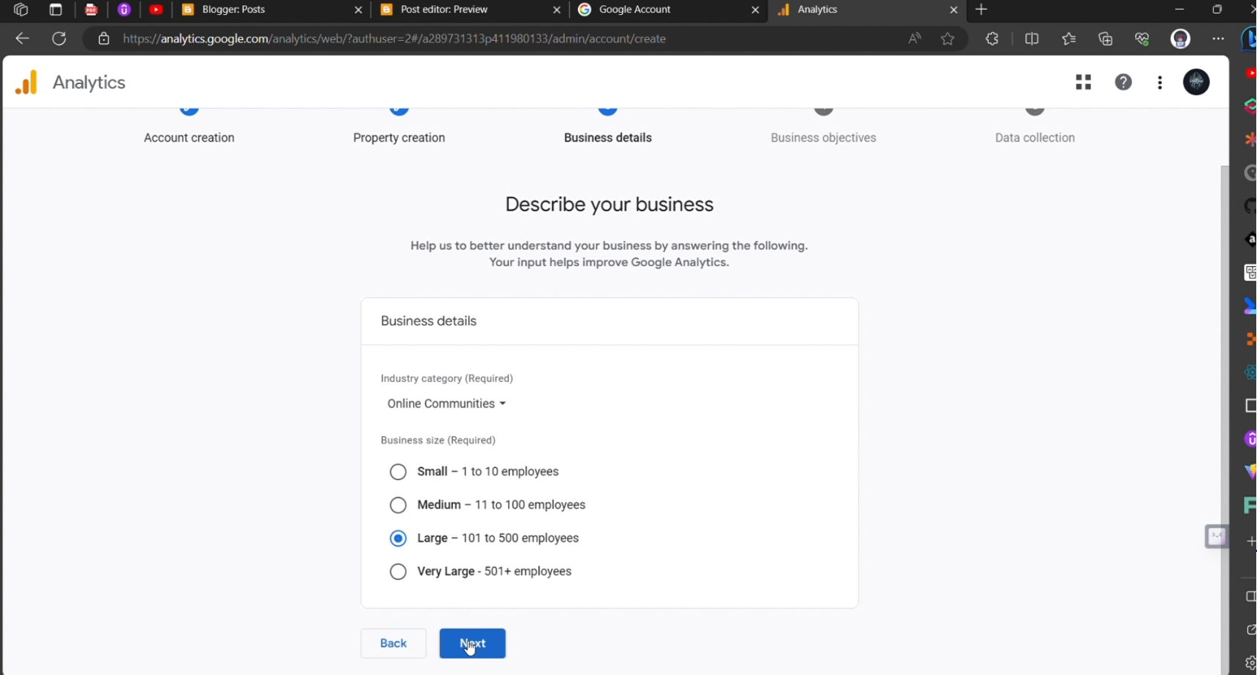

**STEP 8: - CHOOSING A BUSINESS OBJECTIVE**

Select a business objective aligned with your website's goals and strategies, serving as a reference point for performance evaluation.

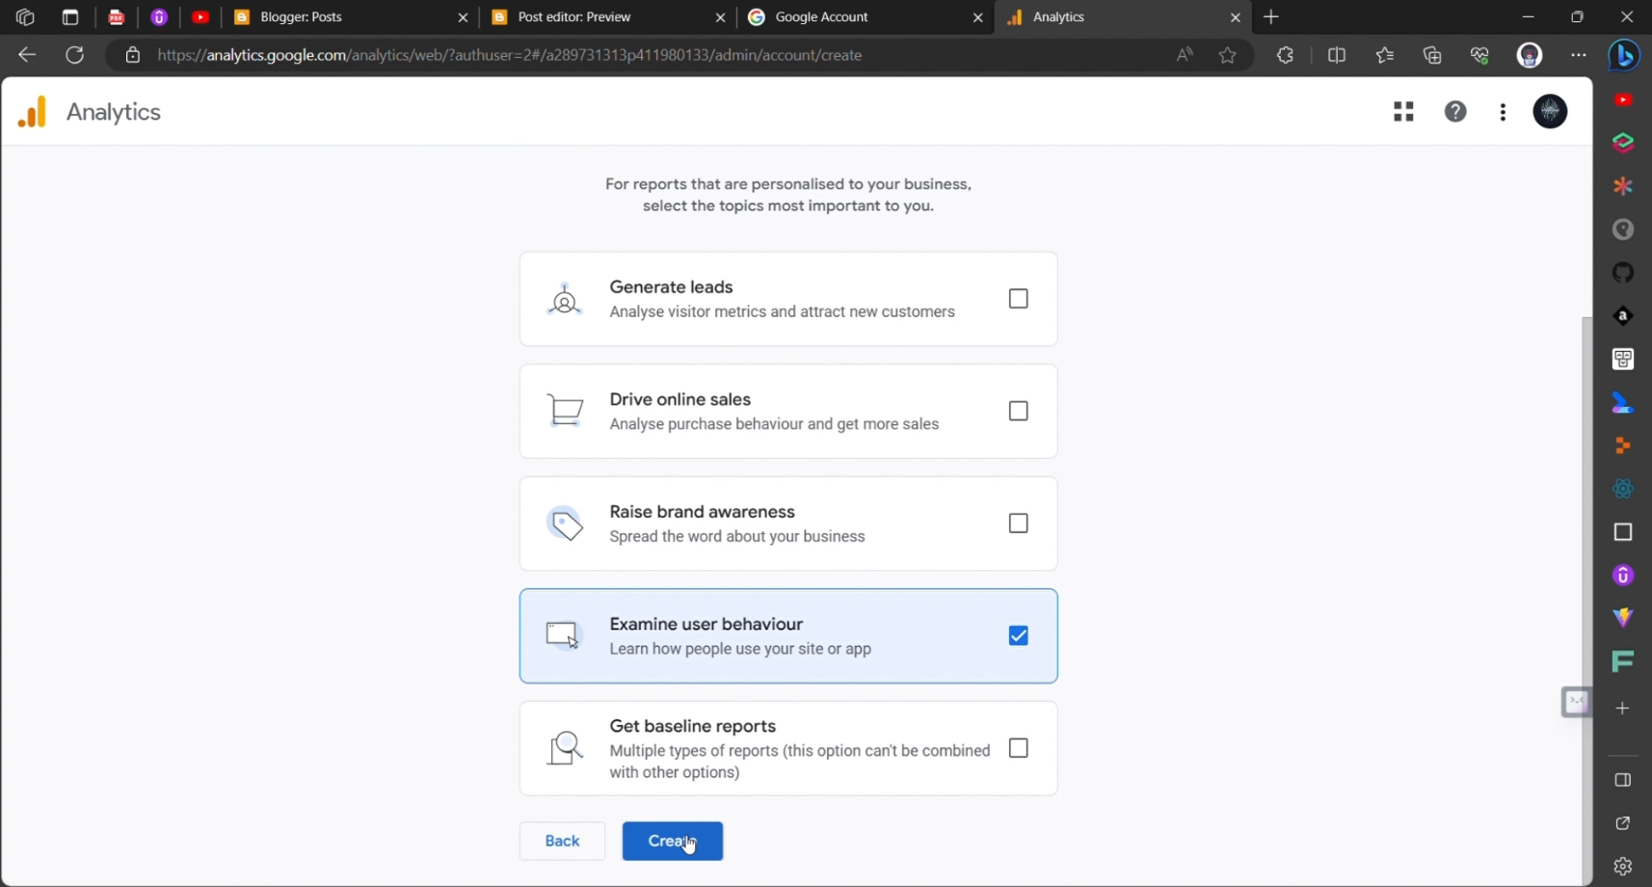

**STEP 9: - CHOOSING A PLATFORM AS WEB**

Specify that your website is a web platform, ensuring that Google Analytics is set up correctly for web tracking.

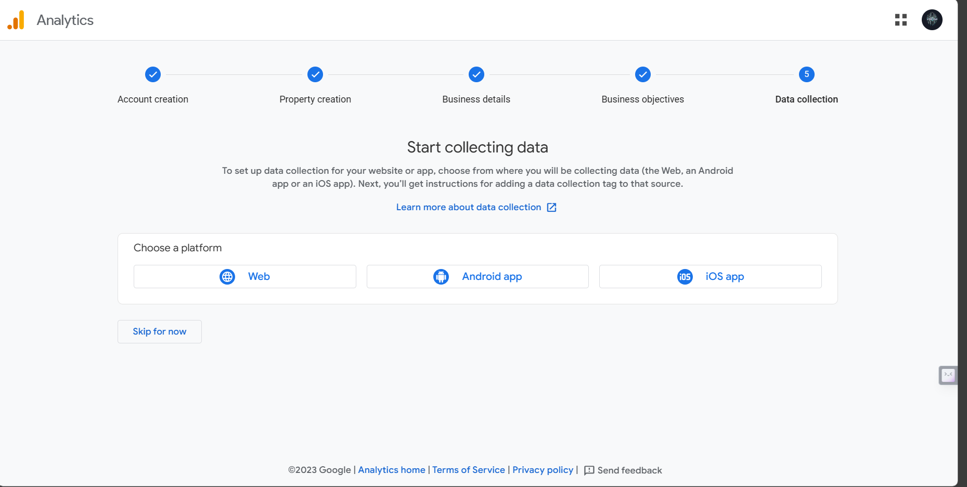

**STEP 10: - SETTING UP A DATA STREAM BY WEBSITE URL**

Create an account within Google Analytics and give it a name corresponding to your website, laying the foundation for data collection.

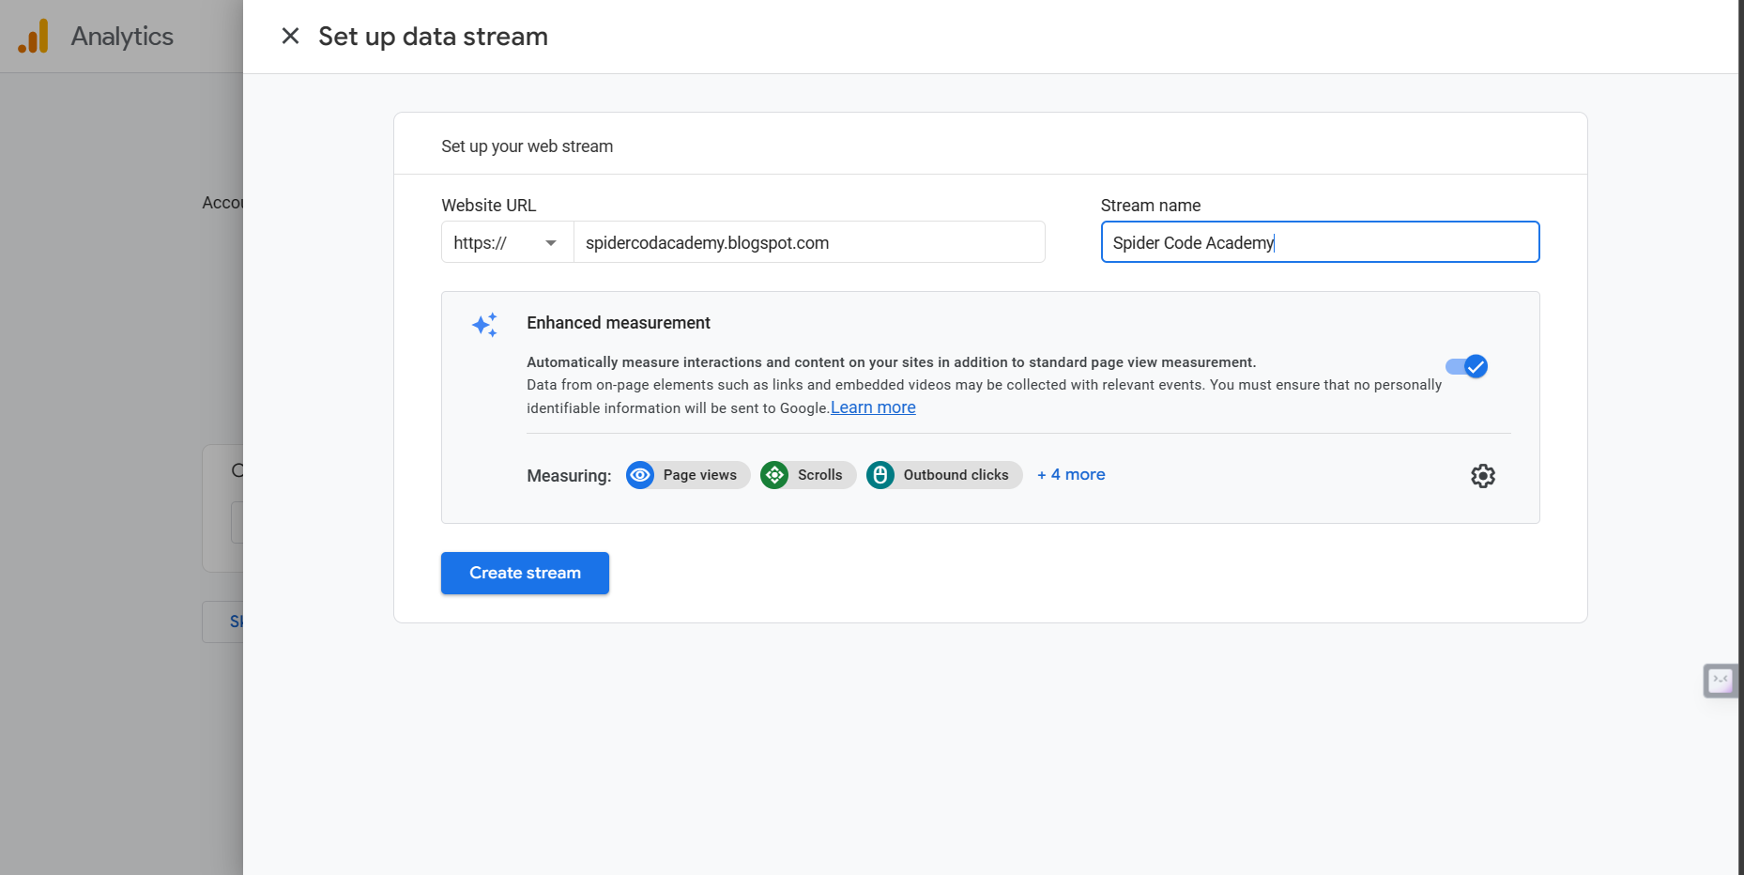

**STEP 11: - GENERATED MEASUREMENT ID WITH TAG INSTRUCTIONS**

After setting up the data stream, receive a unique Measurement ID and tag instructions from Google Analytics, essential for tracking.

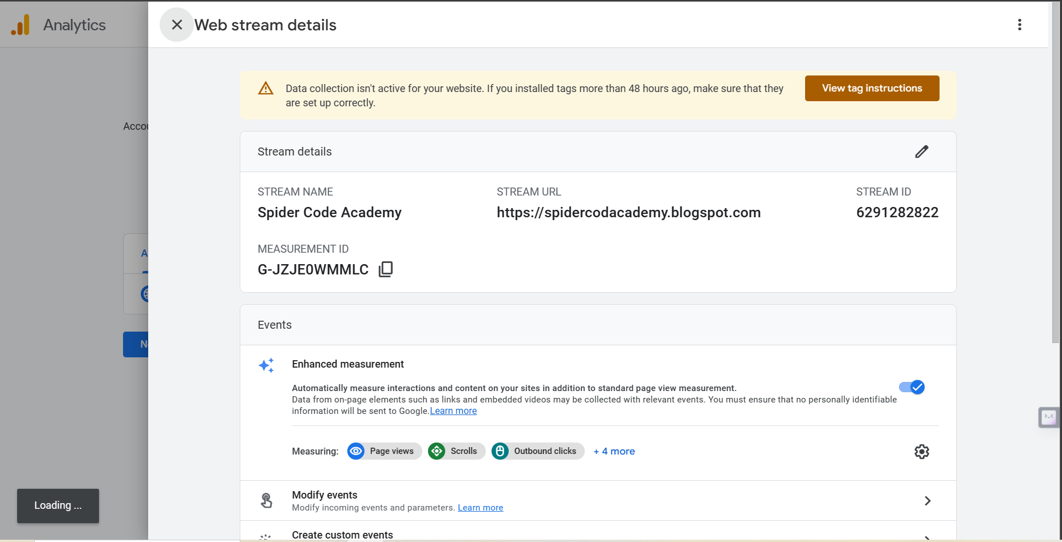

**STEP 12: - COPYING TAG INSTRUCTIONS FOR INSTALLING MANUALLY**

Copy tag instructions provided for manual installation. These tags are crucial for enabling tracking on your website.

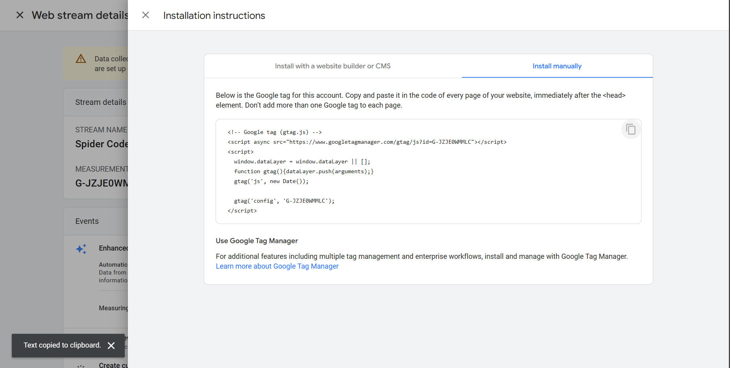

**STEP 13: - EDITING HTML OF BLOGGER WEBSITE IN THEME SECTION**

Access the HTML editor in the Blogger website theme section, allowing you to modify the website's HTML code.

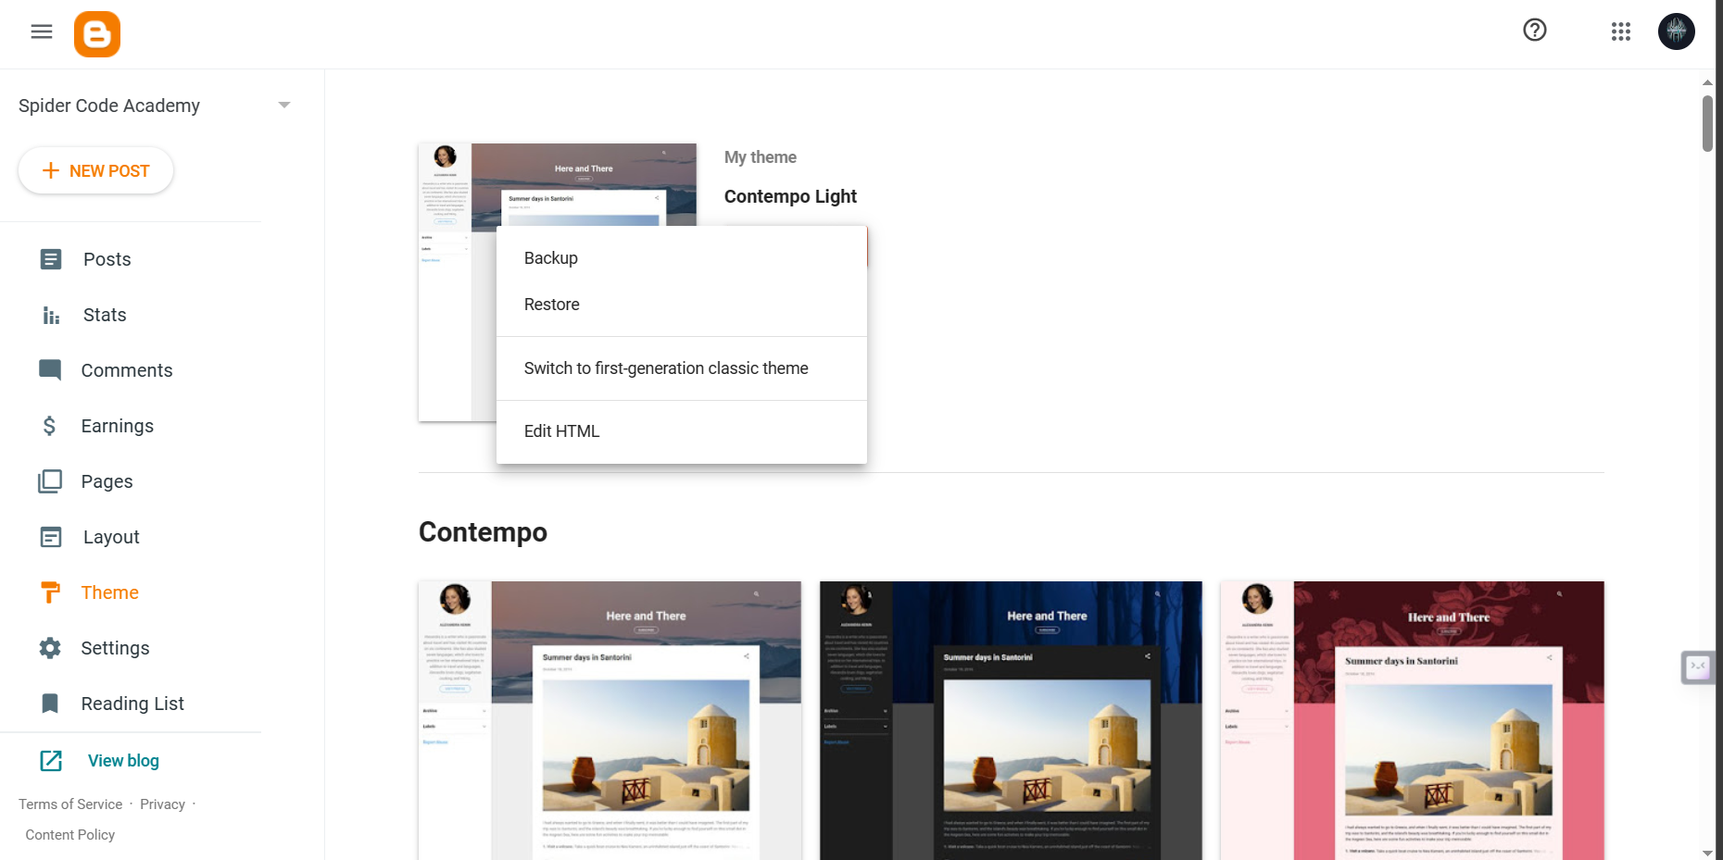

**STEP 14: - PASTING GOOGLE TAG AFTER <HEAD> TAG**

Paste the tag instructions provided by Google Analytics immediately after the opening `<head>` section in your website's HTML code.

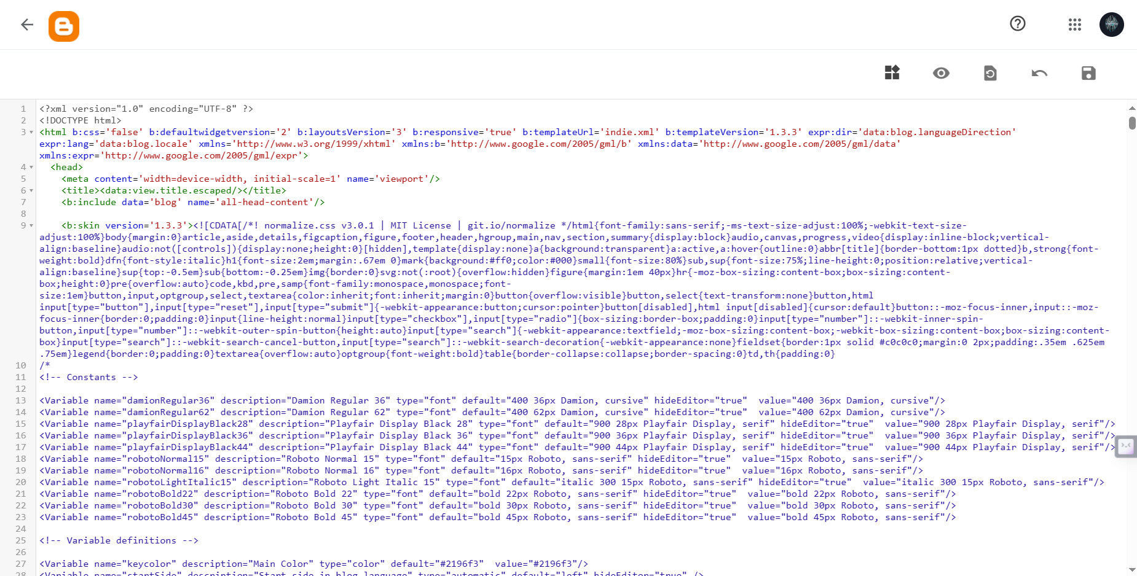

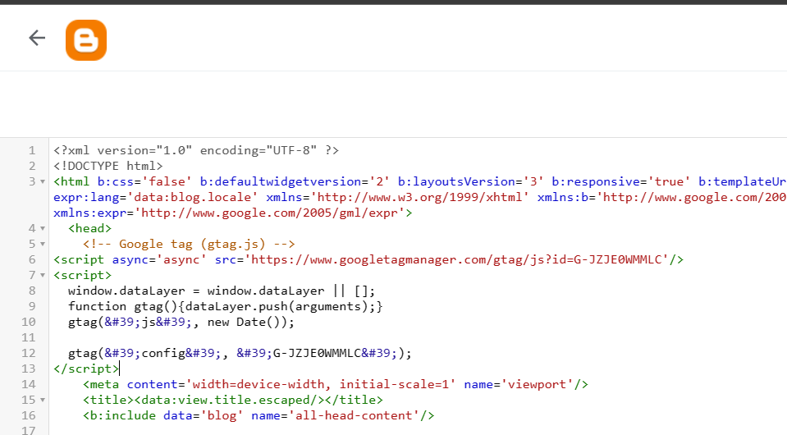

**STEP 15: - GENERATED DATA STREAM AND LINKED GOOGLE ANALYTICS SUCCESSFULLY**

Once the tag instructions are correctly implemented, your website is successfully linked to Google Analytics, initiating data collection for analysis.

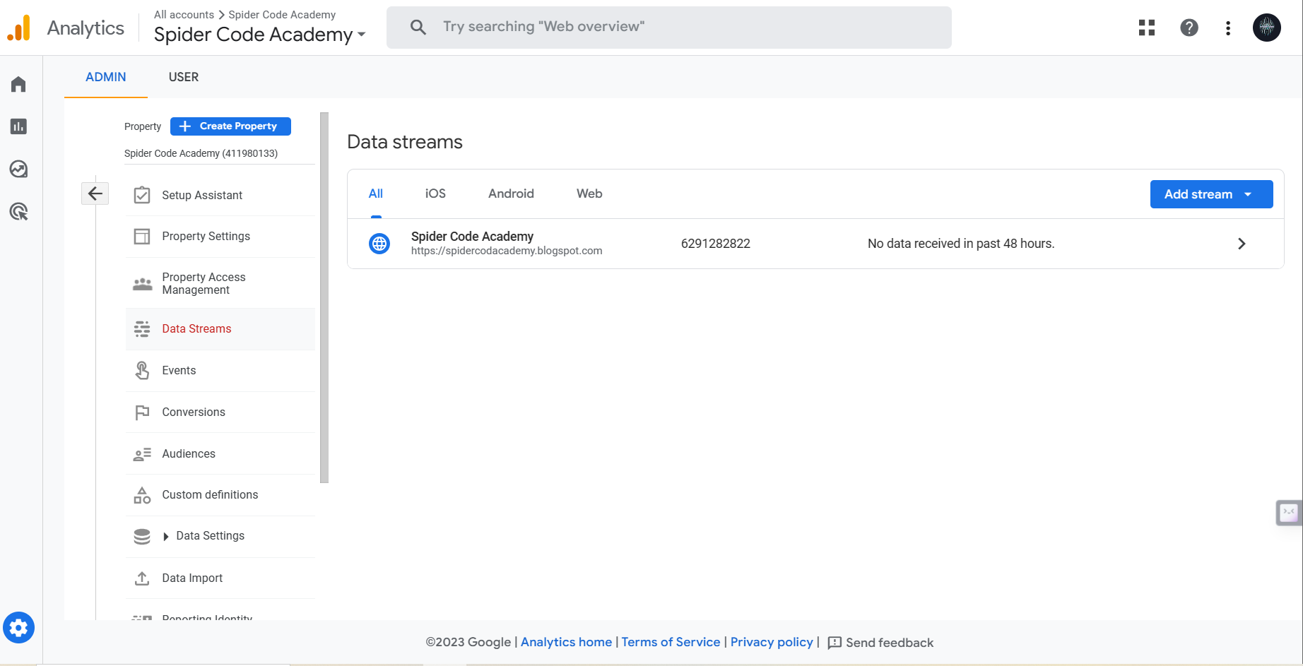

**CONCLUSION**

In the vast digital realm where websites are the storefronts of our online presence, understanding how users interact with your platform is paramount. The "Adding Google Analytics to a Website" ***project provides a systematic roadmap for individuals and businesses*** to gain a deeper understanding of their online audience and, subsequently, make data-driven decisions to enhance their digital performance.

***Google Analytics, with its robust capabilities***, is the keystone of this project. By meticulously following the outlined steps, website owners and administrators can unlock a treasure trove of data-driven insights. Let's reflect on the key takeaways from this journey.

The initial steps include establishing a brand identity and creating a website using the ***user-friendly Blogger.com platform***. These are the foundational building blocks that set the stage for the integration of Google Analytics. Once your website is up and running, the next steps guide you through the setup process within Google Analytics.

Describing your business and setting a clear business objective forms ***the basis for tailored data collection***. Selecting the web platform ensures that Google Analytics is configured for your specific needs.

The pivotal moment arrives with the setup of a data stream by ***linking your website's URL***. This connection forms the bridge that allows Google Analytics to collect and process data. ***Measurement*** ***IDs and tag instructions*** are your passports to successful tracking. Following this, it's time to implement these tags into your website's HTML code.

Editing your website's HTML may seem daunting, but the project simplifies this task. By pasting the tag instructions immediately after the opening `<head>` section, you ***enable Google Analytics to collect data.***

Finally, with your data stream correctly set up and the analytics tags implemented, your website is successfully linked to Google Analytics. This initiates the collection of crucial data, opening doors to ***insights about your website's performance, user behavior, and audience engagement.***

In conclusion, the "Adding Google Analytics to a Website" project ***empowers individuals and businesses, regardless of their digital expertise, to harness the vast potential of web analytics.*** By enabling data-driven decisions, this project paves the way for enhanced online performance and more meaningful user experiences. As the digital landscape continues to evolve, the knowledge gained from this project is your compass, guiding you to navigate and excel in the ever-changing online world.

# OUR PROJECT LINKS

GOOGLE TAG:

<!-- Google tag (gtag.js) -->   
<script async src="https://www.googletagmanager.com/gtag/js?id=G-JZJE0WMMLC"></script>   
<script> window.dataLayer = window.dataLayer || []; function gtag(){dataLayer.push(arguments);} gtag('js', new Date()); gtag('config', 'G-JZJE0WMMLC'); </script>

BLOGGER.COM LINK: https://spidercodacademy.blogspot.com/2023/10/welcome-to-spider-code-academy.html

GITHUB LINK: https://github.com/Dinesh-comarde/DIGITAL-MARKETING-NM2023TMID01931

VIDEO DEMO LINK: https://drive.google.com/drive/folders/1FQ4TEO6d6DNIp801I-I1lNd029AGhMn4?usp=sharing